**1.Problem Name:**

Write a C program to find maximum between two numbers using if else. C program to input two numbers from user and find maximum between two numbers using if else. How to find maximum or minimum between two numbers using if else in C programming.

**Source Code:**

#include<stdio.h>

int main ()

{

int num1=10,num2=20;

if(num1>num2)

printf("Max =%d",num1);

else

printf("Min =%d",num2);

return 0;

}

**Output:**

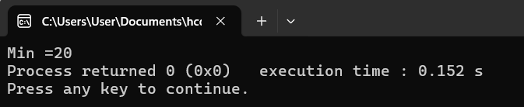

**2. Problem name:**

Write a C program to find maximum between three numbers using ladder if else or nested if. How to find maximum or minimum between three numbers using if else in C programming. Logic to find maximum or minimum between three numbers in C program.

**Source Code:**

#include <stdio.h>

int main(){

int a, b, c;

printf("Enter three numbers: ");

scanf("%d %d %d", &a, &b, &c);

if (a >= b && a >= c)

{

printf("Maximum number is: %d\n", a);

}

else if (b >= a && b >= c)

{

printf("Maximum number is: %d\n", b);

}

else

{

printf("Maximum number is: %d\n", c);

}

return 0;

}

**OUTPUT:**

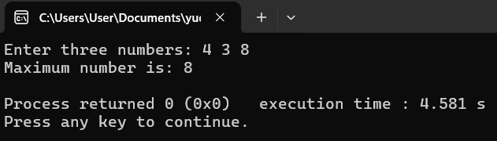

**Problem-3:**

C program to check whether a number is positive, negative or zero.

**Source Code:**

include <stdio.h>

int main()

{

int num;

printf("Enter a number: ");

scanf("%d", &num);

if(num > 0)

{

printf("%d is Positive\n", num);

}

else if (num < 0)

{

printf("%d is Negative\n", num);

}

else

{

printf("The number is Zero\n");

}

return 0;

}

**OUTPUT:**

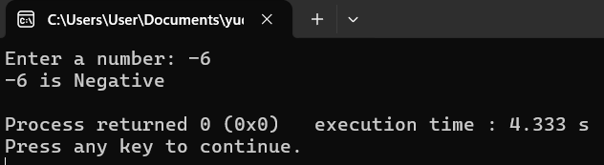

**Problem-4:**

C program to check whether a number is divisible by 5 and 11 or not.

**Source Code:**

#include <stdio.h>

int main()

{

int num;

printf("Enter a number: ");

scanf("%d", &num);

if (num % 5 == 0 && num % 11 == 0)

{

printf("%d is divisible by both 5 and 11\n", num);

}

else

{

printf("%d is not divisible by both 5 and 11\n", num);

}

return 0;

}

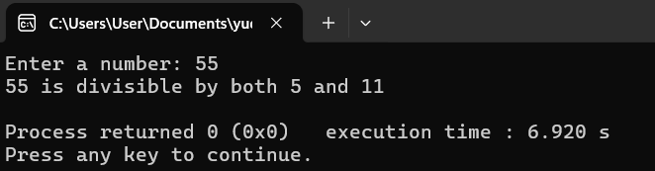

**Problem-5:**

C program check whether a number is even or odd.

**Source Code:**

#include <stdio.h>

int main()

{

int num;

printf("Enter a number: ");

scanf("%d", &num);

if(num % 2 == 0)

{

printf("%d is Even\n", num);

}

else

{

printf("%d is Odd\n", num);

}

return 0;

}

**OUTPUT:**

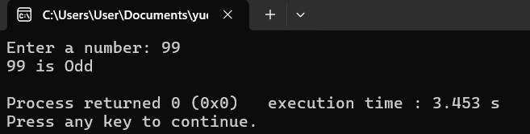

**Problem-6:**

C program to check Leap Year.

**Source Code:**

#include <stdio.h>

int main()

{

int year;

printf("Enter a year: ");

scanf("%d", &year);

if ((year % 4 == 0 && year % 100 != 0) || (year % 400 == 0))

{

printf("%d is a Leap Year\n", year);

}

else

{

printf("%d is not a Leap Year\n", year);

}

return 0;

}

**OUTPUT:**

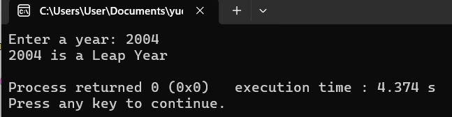

**Problem-7:**

C program to check whether a character is alphabet or not.

**Source Code:**

#include <stdio.h>

int main()

{

char ch;

printf("Enter a character: ");

scanf("%c", &ch);

if ((ch >= 'A' && ch <= 'Z') || (ch >= 'a' && ch <= 'z'))

{

printf("%c is an Alphabet\n", ch);

}

else

{

printf("%c is not an Alphabet\n", ch);

}

return 0;

}

**Output:**

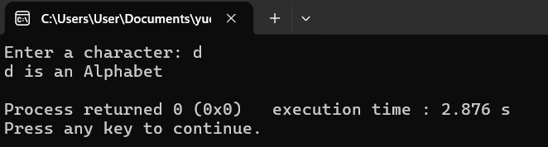

**Problem-8:**

C program to check vowel or consonant.

**Source Code:**

#include <stdio.h>

int main() {

char ch;

printf("Enter an alphabet: ");

scanf("%c", &ch);

if ((ch >= 'A' && ch <= 'Z') || (ch >= 'a' && ch <= 'z')) {

if (ch == 'A' || ch == 'E' || ch == 'I' || ch == 'O' || ch == 'U' ||

ch == 'a' || ch == 'e' || ch == 'i' || ch == 'o' || ch == 'u') {

printf("%c is a Vowel\n", ch);

}

else

{

printf("%c is a Consonant\n", ch);

}

}

else

{

printf("%c is not an alphabet\n", ch);

}

return 0;

}

**Output:**

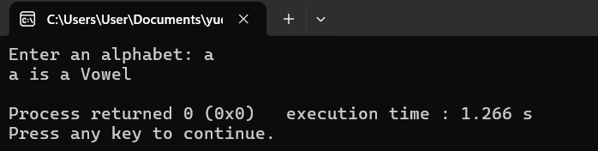

**Problem-9:**

C program to check whether a character is alphabet, digit or special character.

**Source Code:**

#include <stdio.h>

int main()

{

char ch;

printf("Enter a character: ");

scanf("%c", &ch);

if ((ch >= 'A' && ch <= 'Z') || (ch >= 'a' && ch <= 'z'))

{

printf("%c is an Alphabet\n", ch);

}

else if (ch >= '0' && ch <= '9')

{

printf("%c is a Digit\n", ch);

}

else

{

printf("%c is a Special Character\n", ch);

}

return 0;

}

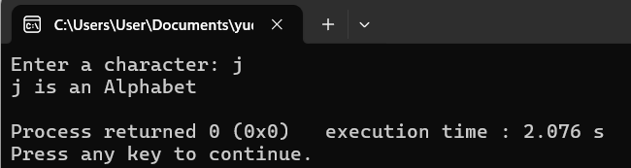

**Problem-10:**

C program to check whether a character is Uppercase or Lowercase.

**Source Code:**

#include <stdio.h>

int main()

{

char ch;

printf("Enter a character: ");

scanf("%c", &ch);

if (ch >= 'A' && ch <= 'Z')

{

printf("%c is Uppercase\n", ch);

}

else if (ch >= 'a' && ch <= 'z')

{

printf("%c is Lowercase\n", ch);

}

else

{

printf("%c is not an alphabet\n", ch);

}

return 0;

}

**Output:**

